**Module:**

## **Website & Mobile Design & Development (2017)**

**Group CA2 -Website**

**Site Structure & Navigation**

**Continuous Assessment 2**

**Value: 30%**

**Lecturer: Jelena Vasic**

**Submission Date: 10th November 2017**

**Student Details:**

**Carl Promnitz X00130365**

**Sean Slattery X00136210**

# **Sections**

[1b - 1] - Home Page Layout Scan

[1b - 2] - Game Pages Layout Scan

[1b - 3] - Teams Pages Layout Scan

[1b - 4] - Tournaments Pages Layout Scan

[1b - C] - Contributions

**[1b-1]- Home Page Layout Scan**

As described in the website’s Structure and Navigation document, the page will have a Navigation bar that goes from left to right across the top of the page. That is also a drop-down menu for a link to the teams and tournaments of each game when hovered over.

There will be a login button and search bar on the right top of the page as seen in the scan. We decided that it will best to have the page colored a dark grey color i general.

The body’s content will be divided by white border lines with the images being on the left of the page and the bodies of text will on the right.

The home layout will have a large banner of a filled eSports stadium. Followed by the large header of a welcome message to the website, followed by a description of how large eSports is in this current time.

The lower part of the body will have the four games (League of Legends, Counter-Strike: Global Offensive, SMITE and Overwatch) that will be the focus of our website and their major eSports scenes. Accompanied by a large image of the game’s logo on the left of the page, and a description of the game of what’s it about and a description of the their eSports.

The text for all pages will be white mostly as it helps to make the text and information stand out to the readers/users of the site.

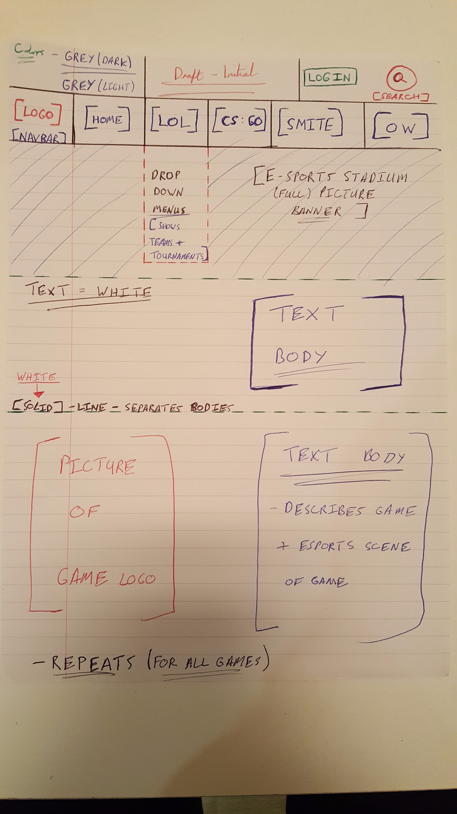

**[1b-2]- Games Pages Layout Scan**

All pages that have a game will follow the same layout. The design for the color scheme, Navigation bar, and elements on the top of the page will remain consistent throughout the website.

All game pages will have a large banner logo of their game in the first section of the body, followed by a simular description of what the game is about and it’s eSports scene.

The bottom half will have a divided section for a direct link to the teams and tournaments related to the game. Users can click on the picture that will take them to the page, when hovered over, a header for team and tournaments will show up for each picture.

There will be comment section at the bottom of the page for account users and admins to leave messages about what they think, ect.

\***(NOT SHOWN IN DIAGRAM)**

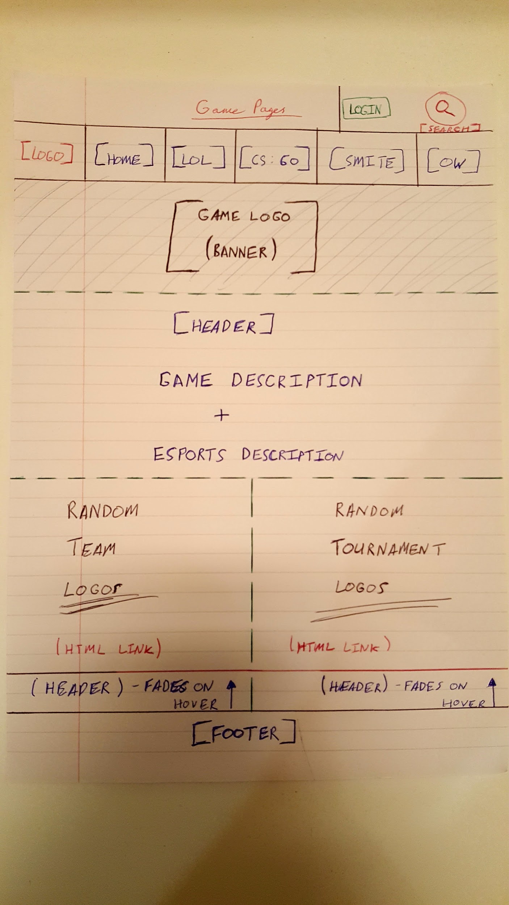

**[1b-3]- Teams Pages Layout Scan**

All pages that have teams will follow the same layout. The design for the color scheme, Navigation bar, and elements on the top of the page will remain consistent throughout the website.

The layout of the page will consist of the team’s images being on the left part of the page and their description on the right part of the page with a description where they based, what tournaments they have won, and notable players that have been on their team in previous times.

The users are able to click on the team logos to be taken to the team’s official websites as well.

There will be comment section at the bottom of the page for account users and admins to leave messages about what they think, ect.

\***(NOT SHOWN IN DIAGRAM)**

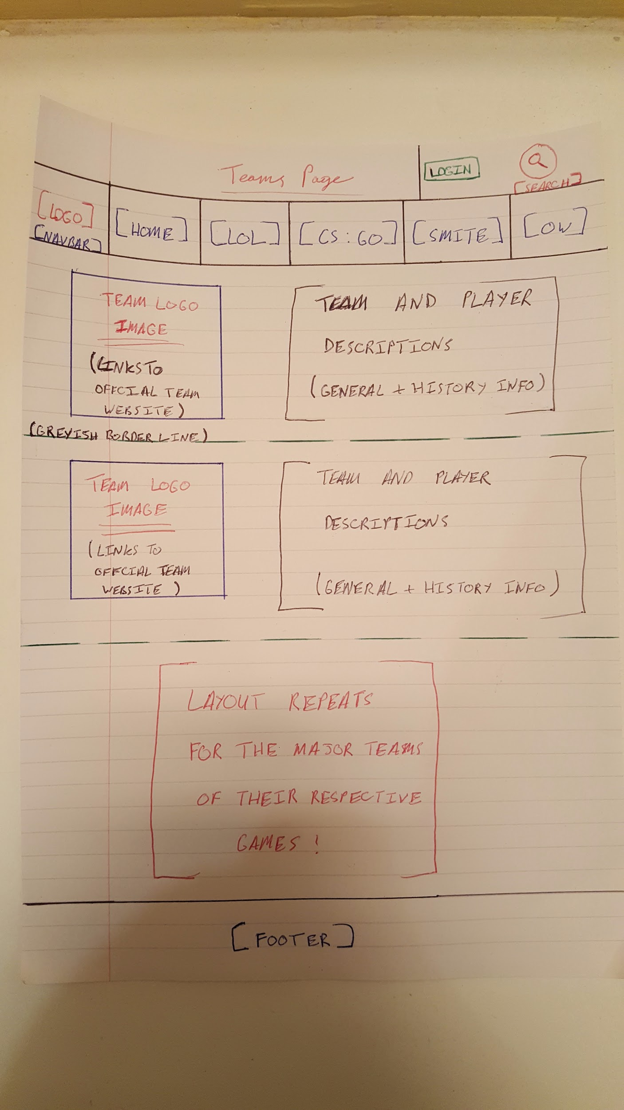

**[1b-4]- Tournaments Pages Layout Scan**

All pages that have tournaments will follow the same layout. The design for the color scheme, Navigation bar, and elements on the top of the page will remain consistent throughout the website.

The layout of the page will consist of the tournaments images being on the left part of the page and their description on the right part of the page with a description where they based, how large the tournament is in the season calendar, and notable teams that have won or come out in the top positions previous;y.

The users are able to click on the tournaments logos to be taken to the tournaments official websites as well.

There will be comment section at the bottom of the page for account users and admins to leave messages about what they think, ect.

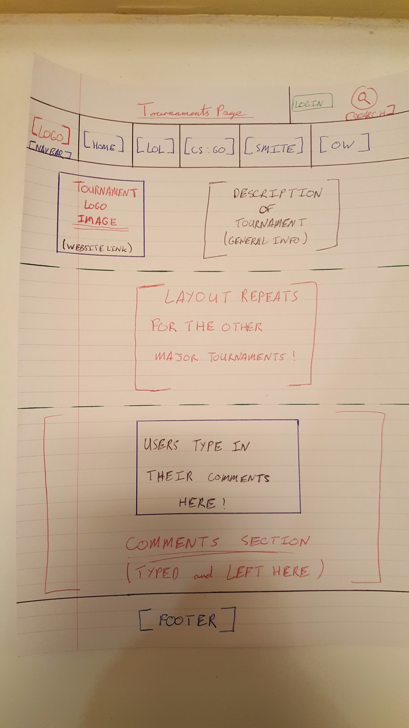

**[1b-C]- Contibutions**

**Sean Slattery(X00136210) -** Typed up descriptions for each page and drawed out the scans. Helped in the designing the elements that would be parts of the website.

**Carl Promnitz(X00130365) -** Gave links for websites to get ideas for the basis of design for our website, gave major suggestions on elements to be part of our website.

**References**

[**http://esports.smitegame.com/**](http://esports.smitegame.com/) - SMITE

[**http://www.lolesports.com/en_US/**](http://www.lolesports.com/en_US/)- League of Legends (LoL)

[**https://www.thescoreesports.com/csgo/news**](https://www.thescoreesports.com/csgo/news)Counter-Strike: Global Offensive (CS:GO)

[**https://playoverwatch.com/en-us/esports/**](https://playoverwatch.com/en-us/esports/)- Overwatch (OW)